## Lab 4-01: Deploy AWS Shield

### Lab Prerequisites

* Familiarity with basic AWS Cloud Computing concepts and terminology
* An AWS account with an active subscription

### Service Introduction

AWS Shield is a managed protection solution protecting AWS-hosted web applications from Distributed Denial-of-Service (DDoS) attacks. It provides always-on detection with automatic inline mitigations, lowering application latency and downtime. A Denial-of-Service (DoS) attack is a malicious attempt to make a targeted system unavailable by flooding it with packets or requests, causing the system to fail due to the excessive traffic volume. Several compromised systems or controlled sources are used to create a DDoS attack.

AWS Shield Standard protects against more commonly occurring Infrastructure (OSI layer 3 and layer 4) attacks such as SYN/UDP Floods, Reflection attacks, and others to maintain the high availability of applications on AWS.

AWS Shield Advanced delivers enhanced protection against larger and more sophisticated attacks through the flow-based monitoring of network traffic and active application scrutiny, which can notify system hosts of incoming DDoS attacks in near real-time. Customers can take immediate action to mitigate the attack using highly flexible controls.

### Case Study Enterprise Financial Services – Capital Finance

Background

Capital Finance is a customer-centric global financial services group founded in 1990. The company dominates the Spanish market, is Sweden's largest financial institution and has leading franchises in South America and the Sunbelt Region.

Capital Finance manages eight data centers in Europe and the USA. The company is currently hosting more than 100+ internal and external applications. The company is currently in the process of consolidating its customer-facing financial applications. The company development team is working on a new global all-in-one SaaS banking platform for managing credit and deposit products quickly, simply, and affordably. It will give Capital Finance a clear edge in the financial sector.

The Sales and Marketing team has projected a tenfold growth in customer traffic in the next two years after launching the SaaS application. The management is highly concerned about the following:

* Increased data center footprint
* Time to market
* Security and compliance
* IT operations cost
* Scaling to market demands
* Increasing business agility

At Capital Finance, the central motivating belief is that the winners in next-generation banking will be the companies that make the most creative and innovative use of technology to provide seamless, intelligent, truly excellent customer experiences.

You are working as a consultant for Capital Finance. You will solve a number of business and technical challenges as part of this case study.

Business Challenge

The Capital Finance business development team is launching a WordPress website for a new financial application. The business development team is very much concerned about the security of their newly created web application. They asked the CTO of the company to protect the web application from Distributed Denial-of-Service (DDoS) attacks. The management has directed the CTO to explore the AWS Cloud provider solution to address the current challenge.

Proposed Solution

The CTO of Capital Finance has spoken with several Cloud and on-premises security solution providers about the current challenges. It has been concluded that AWS Shield, which is a managed protection solution that protects AWS-hosted web applications from Distributed Denial-of-Service (DDoS) attacks, is the best solution for the current challenge.

Lab Diagram

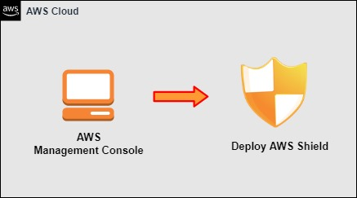

Figure 4-05: AWS Shield

Implementation Steps

1. Deploy an AWS Shield.

### Solution

|  |
| --- |
| **Step 1: Deploy an AWS Shield**   1. Log in to **AWS Management Console**. 2. Click on **Services**. 3. Scroll down to **Security, Identity & Compliance**. 4. Select **WAF & Shield**.      1. Go to **AWS Shield** and click on **Getting started**.      1. Go to **AWS Shield tier comparison** to determine **Standard and Advanced** version options. |

## Lab 4-02: Deploy AWS Inspector

### Lab Prerequisites

* Familiarity with basic AWS Cloud Computing concepts and terminology
* An AWS account with an active subscription

### Service Introduction

AWS Inspector is an automated security assessment service to improve the security and compliance of the applications running on Amazon EC2.

After assessing applications for vulnerabilities or deviations from best practices, it provides a thorough list of security findings in order of severity. Amazon Inspector is an API-driven service that makes it easy to deploy, manage and automate.

While using Amazon Inspector's assessment target is defined, including collecting AWS resources to be monitored. Eventually, a security assessment run of the target is launched. A complete detailed assessment report is then delivered via the Amazon Inspector console or API. This report includes a list of findings for potential security issues discovered after analyzing and monitoring the network, process activity, and the specified target file system.

### Case Study Enterprise Financial Services – Capital Finance

Background

Capital Finance is a customer-centric global financial services group founded in 1990. The company dominates the Spanish market, is Sweden's largest financial institution and has leading franchises in South America and the Sunbelt Region.

Capital Finance manages eight data centers in Europe and the USA. The company hosts more than 100+ internal and external applications. It is currently in the process of consolidating the customer-facing financial applications. The company’s development team is working on a new global all-in-one SaaS banking platform for managing credit and deposit products quickly, simply, and affordably. It will give Capital Finance a clear edge in the financial sector.

The Sales and Marketing team has projected a tenfold growth in customer traffic in the next two years after launching the SaaS application. The management is highly concerned about the following:

* Increased data center footprint
* Time to market
* Security and compliance
* IT operations cost
* Scaling to market demands
* Increasing business agility

At Capital Finance, the central motivating belief is that the winners in next-generation banking will be the companies that make the most creative and innovative use of technology to provide seamless, intelligent, truly excellent customer experiences.

You are working as a consultant for Capital Finance. You will solve several business and technical challenges as part of this case study.

Business Challenge

The Capital Finance business development team is launching a WordPress website for a new financial application. The business development team is very much concerned about the security of their newly created web application. They asked the CTO of the company to integrate an assessment service that monitors the overall activity of the web servers and generates an assessment report after assessing the web servers.

The management has directed the CTO to explore the AWS Cloud provider solution to address the current challenge.

Proposed Solution

The CTO of Capital Finance has spoken with several Cloud and on-premises security solution providers about the current challenges. It has been concluded that AWS Inspector, an automated security assessment service to improve the security and compliance of the applications running on Amazon EC2, is the best solution for the current challenge. After assessing applications, a complete detailed assessment report is delivered via the Amazon Inspector console or API. This report includes a list of findings for potential security issues discovered after analyzing and monitoring the network, process activity, and the specified target file system.

Lab Diagram

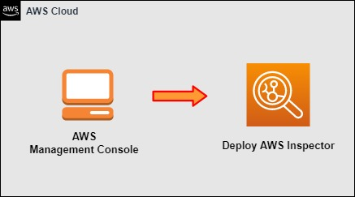

Figure 4-07: AWS Inspector

Implementation Steps

1. Deploy an AWS Inspector.

### Solution

|  |
| --- |
| **Step 1: Deploy an AWS Inspector**   1. Log in to the **AWS Management Console**. 2. Click on **Services**. 3. Scroll down to **Security, Identity & Compliance**. 4. Select **Inspector**.      1. Click on **Get started.**      1. Then, click on **Enable Inspector** to start inspecting.      1. You will now see the report. |

## Lab 4-03: Deploy AWS Trusted Advisor

### Lab Prerequisites

* Familiarity with basic AWS Cloud Computing concepts and terminology
* An AWS account with an active subscription

### Service Introduction

AWS Trusted Advisor is an online resource for optimizing your AWS environment by following AWS best practices. It helps you identify how to configure the resources you can use to reduce cost, increase performance, and improve security. Trusted Advisor is a personalized cloud expert who inspects your AWS environment and gives you real-time advice. It is not just a security tool; it works as a comprehensive analyzer that will tell you how well your infrastructure operates and provide a report with actionable recommendations.

### Case Study Enterprise Financial Services – Capital Finance

Background

Capital Finance is a customer-centric global financial services group founded in 1990. The company dominates the Spanish market, is Sweden's largest financial institution and has leading franchises in South America and the Sunbelt Region.

Capital Finance manages eight data centers in Europe and the USA. The company hosts more than 100+ internal and external applications. It is in the process of consolidating customer-facing financial applications. The company’s development team is working on a new global all-in-one SaaS banking platform for managing credit and deposit products quickly, simply, and affordably. It will give Capital Finance a clear edge in the financial sector.

The Sales and Marketing team has projected a tenfold growth in customer traffic in the next two years after launching the SaaS application. The management is highly concerned about the following,

* Increased data center footprint
* Time to market
* Security and compliance
* IT operations cost
* Scaling to market demands
* Increasing business agility

At Capital Finance, the central motivating belief is that the winners in next-generation banking will be the companies that make the most creative and innovative use of technology to provide seamless, intelligent, truly excellent customer experiences.

You are working as a consultant for Capital Finance. You will need to solve a number of business and technical challenges as part of this case study.

Business Challenge

The Capital Finance business development team has subscribed to many AWS services. The business development team wants a solution that recommends security, cost optimization, performance, and fault tolerance. The management has directed the CTO to explore the AWS Cloud provider solution to deal with the current challenge.

Proposed Solution

The CTO of Capital Finance has spoken with a number of cloud and on-premises solution providers about the current challenges. It has been concluded that Trusted Advisor, a personalized cloud expert who inspects your AWS environment and gives you real-time advice, is the suitable solution for the current requirement.

Lab Diagram

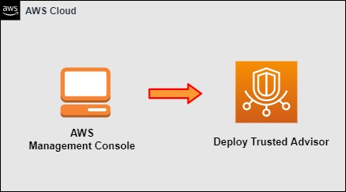

Figure 4-08: AWS Trusted Advisor

Implementation Steps

1. Deploy a Trusted Advisor.

### Solution

|  |
| --- |
| **Step 1: Deploy a Trusted Advisor**   1. Log in to the **AWS Management Console**.      1. Click on **Services**. 2. Scroll down to **Management Tools**. 3. Select **Trusted Advisor**.      1. Click the **Refresh** logo at the top right corner to re-run all the Cost Optimization, Performance, Security, and Fault Tolerance checks. |

## Lab 4-04: Deploy AWS CloudTrail

### Lab Prerequisites

* Familiarity with basic AWS Cloud Computing concepts and terminology
* An AWS account with an active subscription

### Service Introduction

CloudTrail monitors API calls in the AWS platform. CloudTrail is like a CCTV camera, and it records everything that is going on in your AWS environment. Furthermore, it gives you increased visibility into your AWS environment by recording AWS Management Console actions and API calls. AWS CloudTrail will record when a new user, group, or role is created, as well as when an EC2 instance or an S3 bucket is created, so you can see which users and accounts are called AWS, the source IP address from which the calls were made, and when the calls occurred. Everything will be stored in S3.

### Case Study Enterprise Financial Services – Capital Finance

Background

Capital Finance is a customer-centric global financial services group founded in 1990. The company dominates the Spanish market, is Sweden's largest financial institution, and has leading franchises in South America and the Sunbelt Region.

Capital Finance is currently managing eight data centers in the Europe and USA region. The company is hosting more than 100+ internal and external applications. It is currently in the process of consolidating the customer-facing financial applications. The company’s development team is working on a new global all-in-one SaaS banking platform for managing credit and deposit products quickly, simply, and affordably. It will give Capital Finance a clear edge in the financial sector.

The Sales and Marketing team has projected a tenfold growth in customer traffic in the next two years after launching the SaaS application. The management is highly concerned about the following,

* Increased data center footprint
* Time to market
* Security and compliance
* IT operations cost
* Scaling to market demands
* Increasing business agility

At Capital Finance, the central motivating belief is that the winners in next-generation banking will be the companies that make the most creative and innovative use of technology to provide seamless, intelligent, truly excellent customer experiences.

You are working as a consultant for Capital Finance. You will need to solve a number of business and technical challenges as part of this case study.

Business Challenge

The Capital Finance business development team has subscribed to many AWS services. The business development team wants a solution that records everything going on in your AWS environment. The management has directed the CTO to explore the AWS Cloud provider solution to deal with the current challenge.

Proposed Solution

The CTO of Capital Finance has spoken with a number of cloud and on-premises solution providers about the current challenges. It has been concluded that CloudTrail is the best choice for the required challenge. CloudTrail is like a CCTV camera, and it records everything that is going on in your AWS environment. Furthermore, it gives you increased visibility into your AWS environment by recording AWS Management Console actions and API calls.

Lab Diagram

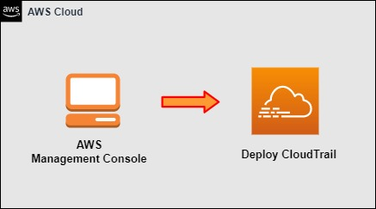

Figure 4-09: CloudTrail

Implementation Steps

1. Deploy a CloudTrail.

### Solution

|  |
| --- |
| **Step 1: Deploy a CloudTrail**   1. Log in to **AWS Management Console**. 2. Click on **Services**. 3. Go to **Management and Governance**. 4. Click on **CloudTrail.**      1. Click on **Create a trail**.      1. Give a **name** to your **Trail**. 2. Click on **Create trail**. |